**AIM:**  Design NFA using simulator to accept the string that start and end with different symbols over the input {a,b}.

**INPUT:**

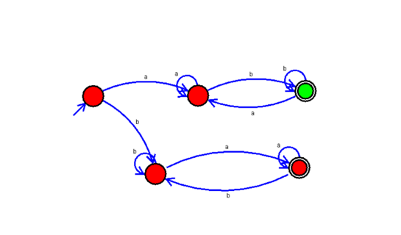

**OUTPUT:**

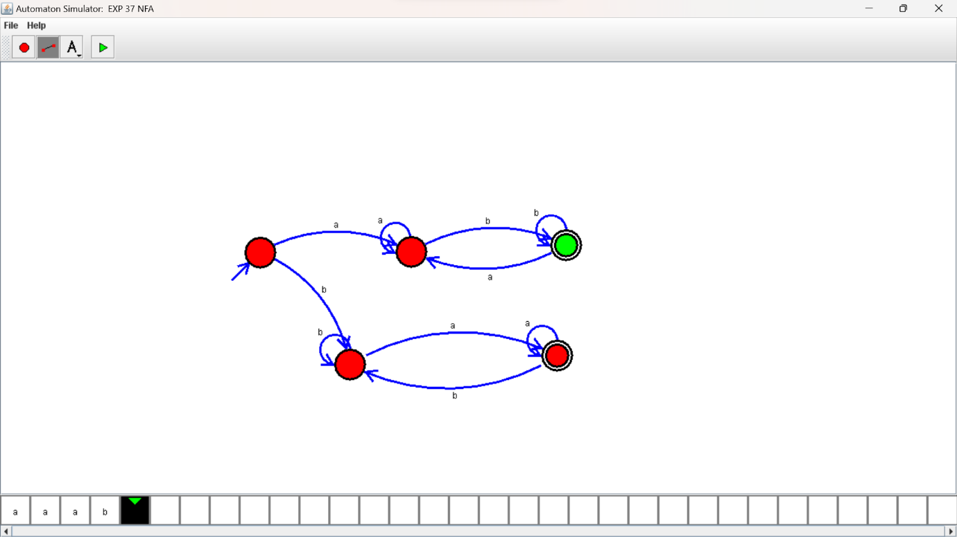

**RESULTS:**

NFA using simulator to accept the string that start and end with different symbols over the input {a,b}.